# Assignment 2 – Intelligent robotics

Our task was to create interaction loop between iCub robot and visual input using YARP and iCub simulator. The program has a capability to detect face and circle, follow it with his eyes and is capable of making a simple gesture when he recognises some specific object.

Yarp (Yet Another Robot Platform, http://www.yarp.it/) is responsible for a communication with robot in a peer-to-peer way using most popular connection types and using Observer design pattern. We are extensively working with this platform to obtain robots visual perception or transfer USB camera feed to robot.

All computer vision tasks were handled using OpenCV library (we tried to use ArUco library for augment reality application but there we hit a problem with linking libraries). OpenCV is a computer vision library (<https://opencv.org/>) that allows for an efficient real-time application. We use it for face detection with Cascade Classifier and circle detection using Hough Circle Transform.

# Step 1 and 2 - Test setup

To test our program, we performed a simple test (Abbildung 1). In this case one or more users look at a computer screen and a webcam. The webcam picture is projected into a screen in the test simulation. In the test simulation is one robot who looks at the screen. Between the screen and the robot is a table with a blue ball on it. The robots’ left camera applies the necessary filter on the input image, and projects the output image back on a real monitor. The user can see the image output on the monitor. There is also a spectator camera, which overviews computer simulation. The user can see the output of the spectator camera on the real monitor, too.

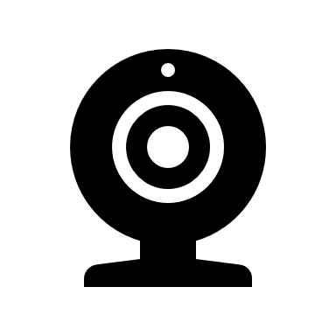

Robot

Table

Blue ball

Screen



Spectator camera

Robots‘left camera

Webcam output

Looks into the camera

looks at the monitor

User

Real monitor

Computer simulation

spectator Output

Robots‘left camera output with applied filters

Webcam

Abbildung 1: The test setup

# Start Parameters

We added two start parameters for our Program to be more flexible for other use cases. When the program is started, the user can specify the input port for the screen as well as the camera which should be used to evaluate the screen. By changing the input port for the screen, it is possible evaluate different input video streams, for example a live webcam stream or a pre-compiled video stream. By changing the evaluation camera, the user can test how the distance or angle will affect the result of the face recognition.

The user must add the start parameters in the start command. For example, one possible start command is: “./assignment2 /grabber /icubSim/cam/left”. The screen will show the input screen of the port “/grabber” and evaluate images of the left robots’ eye. “./assignment2” is the executable of our developed program.

# Step 3

We have implemented 4 different linear filters.

First one, from method Detector::applyLinearFilter(ImageOf<PixelRgb>* yarp_img) is just an example from OpenCV documentation that is just blurring an image using all-one matrix.

Second filter Detector::edgeDetectionFilter uses kernel from <https://en.wikipedia.org/wiki/Kernel_(image_processing)> that is supposed to detect edges, however in current implementation it mostly just darkens an image.

Third one, Detector::cannyEdgefilter uses Canny edge detection, know as well as the optimal detector.

Fourth one, Detector::sobelFilter uses Sobel Derivatives that using approximations of derivatives and other hair-raising math, yields similar results to Canny, however is not that accurate.

Unfortunately, as we encountered some problems with port conflicts, we didn’t manage to display image to another yarp view window, instead we save each image to .jpg file with descriptive name.

# Step 4

After filtering image from camera using one of the functions from step 3, we were capable of using

Haar Cascades for face detection. Haar Cascades are cascades of classifiers that are looking for a human’s face features, as they are pre-generated using machine learning algorithms. In our example implementation we are calculating a centre of face and then drawing an ellipse around face to be sure that algorithms actually works.

This function is also an entry point for step 6.

# Step 5

The goal of step 5 was to implement marker detection using ArUco library or simple circle detection. Unfortunately, we were not able to link ArUco libraries using CMake (I believe there must have been some problem with their compilation) so we decided to implement circle detection.

Circle detection has been implement using Hough Circle Transform and OpenCV method called HoughCircles. To be sure that the function actually works the output image has drawing on it with red circle and green centre of this circle that overlaps detected figure.